Git repository -
Part A:
Setup Repot
Part B:

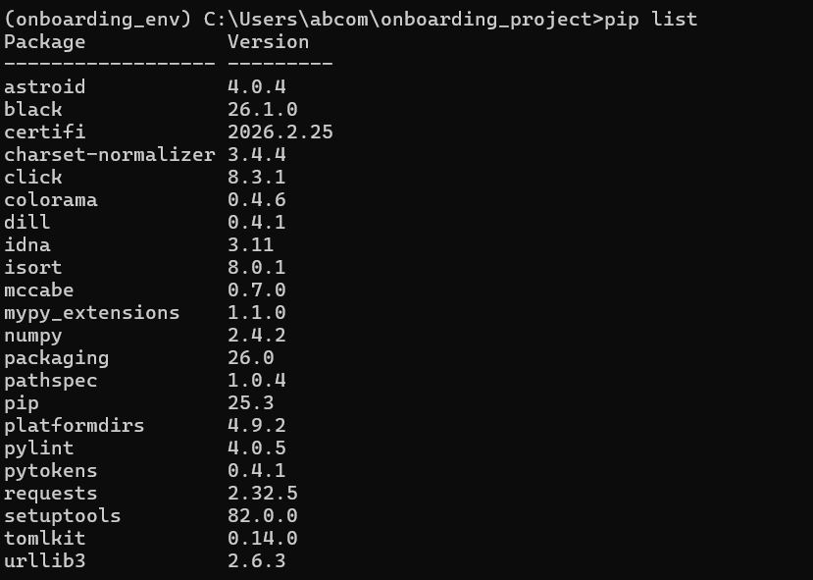
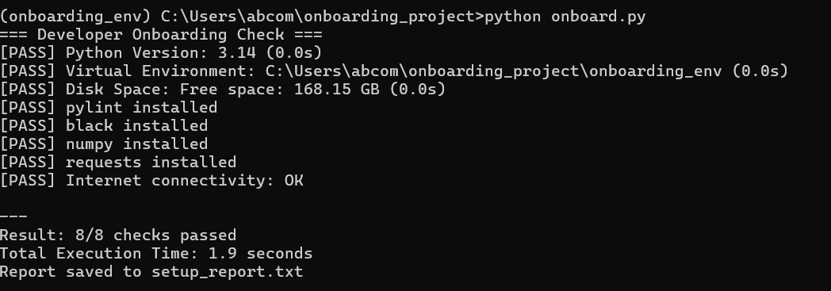

Part C.
Q1: In 3-4 sentences, explain to a non-technical interviewer: What is a Python virtual environment? Why do developers use them? What happens if you don't use one? Give a real-world analogy.
A Python virtual environment is an isolated workspace where dependencies for a project are installed separately from the system Python. Developers use it to avoid conflicts between different project requirements. Without it, installing packages globally can break other applications. It is like having separate rooms for different projects so they don't interfere with each other.
Q2: Coding — Fix and improve this code

import sys
def check_version():
"""Check Python version >= 3.11"""
version = sys.version_info
if version.major == 3 and version.minor >= 11:
return "Good"
return "Bad"
def main():
result = check_version()
print("Version status:", result)
if __name__ == "__main__":
main()
Issues
Multiple imports in one line
Function name not snake_case
Poor condition check
Unused variable (temp)
No docstring
Q3: A junior developer says: "I installed numpy but Python says ModuleNotFoundError: No module named 'numpy'".Give 3 possible causes and the diagnostic command for each.
- Wrong environment
- Installed in different Python version
- Virtual environment not activated

Part D.
Write a critical evaluation (150-200 words): What did the AI get right? What would you change? Did it include any rules that are too strict or too lenient for beginners?
The AI-generated configuration provided a good balance between strictness and flexibility. It disabled overly complex rules like too many arguments and long methods, which is helpful for beginners. However, some rules such as naming conventions were too lenient and may reduce code quality. I would refine it by enforcing basic naming standards and limiting line length to 100 characters. Overall, it serves as a good starting point but requires customization based on project needs.
